Financed from: ………. Agreement no.: ………..

Agreement to complete a job
concluded in accordance with the Labour Code between
Charles University – Faculty of Social Sciences, Praha 1, Smetanovo nábřeží 6
represented by PhDr. Alice Němcová Tejkalová, Ph.D, Dean
(hereinafter referred to as ‘the Employer’)
and Mr/Mrs (title, first name, last name): ………………………
Family name: ……………………………………………..…..……
Health, social insurance: ………………………………..……...…
Contact (e-mail, mobile phone): …………………….……..…….
Permanent address abroad: …………………………………….…

Date of birth: ………………..…………
Birth registration number: ……………
Place of birth: …………………....….…
Passport number: …………..…..……...
Nationality: ……………………..……...
Address in the Czech Republic: …………………………………………..……………………….….…………
In a case of employment of foreign or Czech citizen living abroad please fill out annex no. 1 which is integral part of this agreement.
- The employee undertakes to work for the Employer, at: …………………….
To perform the following duties: ……………………
Classification according to the code CZ - ISCO: …………………….
Education: …………………….
Place of work (location): ……………………
- The work duties shall be performed in the period from ……………. to …………… and the total expected time schedule is not going to exceed ………….. hours.
- Once the agreed work duties are satisfactorily completed, the employee shall receive the remuneration in the amount of ………. CZK per hour. Total amount ………. CZK.
4. The employee agrees with the above data to be used in the fulfilment of duties as stipulated by law 101/2000, Coll., on the protection of personal data.
5. The employee has familiarised himself/herself with the regulations related to the agreed work, especially the occupational health and safety standards. The Employer is obliged to provide suitable conditions for the agreed work.
The remuneration for the work undertaken in accordance with this agreement is payable within the set pay period on the basis of a written confirmation of the work performed, and confirmed by the authorized person and sent to the following bank account: …………….

IBAN: ……………....
SWIFT CODE: …………………..
Name and address of the bank: …………………..

6. Further provisions: ……………………
7. Other provisions are governed by the corresponding regulations of the Labour Code.
8. This agreement is drawn up in two identical copies.
9. The employee understands that according to Law 365/2011, Coll., which amends the Labour Code, the Medical Insurance Act and the Public Health Insurance Act that he/she becomes a participant, i.e. a contributor in the national social and health insurance scheme where the total income exceeds 10.000,- CZK per calendar month. Income from all agreements with the same employer are included in this total, in this case all the faculties and other parts of Charles University, Prague.
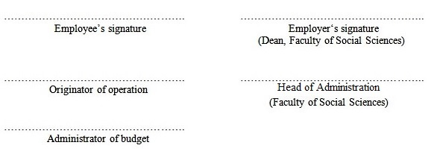
Date: ……………….

Annex. no.1

Other information about foreign or Czech citizen living abroad which are not included in this agreement:

Identity card number: .……………………………….……………………….………..……..

Type of identity card: .……………………………………………………………..…..……..
(I- ID card, P – passport, D – driving licence, O – other)

Country which issued the document: .………………………………………..….……..……..

State of tax residence: .……………………………………………………..…………...……..

Tax identification number in state of tax residence: .………………………….……..………..

Tax ID type: .…………………………………………….…………...….….…………..……..
(tax identifier used in country of the tax residence. R- birth number, D – TIN, S – number of social insurance, J - other)

