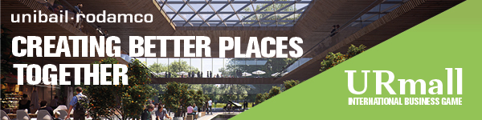

|  |
| --- |
|  |
|  |
| Dear Students,  **Want to take on a stimulating challenge and create Better Places?**  Unibail-Rodamco, the n°1 European listed commercial property company, is glad to announce the 4th edition of **URmall** **International Business Game**. The URmall Business Game gives you the unique possibility to show your skillset by working on a challenging project to transform Shopping Centres into Better Places.   * Work with start-ups and our managers to transform shopping centres * Meet people from top European schools and work on a strategic project * Experience our culture and discover our jobs and people * Attend a 2-day European final in Paris * Present your project to the CEO and Management Board members of Unibail-Rodamco * Be fast-tracked into our European Graduate Programme * Win valuable and exciting rewards   Want to know what it looks like? [Watch the teaser video](https://www.youtube.com/watch?v=hH4DEDrPgxA)  To know more about URmall and apply, [check out our website](https://unibailrodamco.wd3.myworkdayjobs.com/en-US/ur_career_site/job/URmall-Business-Game_JBR_00000229).  Make sure to upload your English CV before 5 November 11.59PM. You will be informed once the deadline is over, to let you know if you made it to the next stage.  Looking forward to meet you in Prague and Paris!  *https://gallery.mailchimp.com/a4ef16fe0381dc9eff8d116d5/images/f9b74d21-7d77-4082-b8d9-306a032743b5.png* |
|  |