FAQs Online pre-departure meeting
Academic Information
CAS, SIS, Faculty Email,…

Q: To log into SIS, do we use our email as a username or the ID number?
IO: To log into SIS you use your personal ID number as a username.

Q: Is it possible to check now how many non-exchange students have already enrolled for a course so that we can look for alternatives if it is overbooked?
IO: this is not possible to find out until the registration is open for you.

Q: Do we immediately sign up for all courses for the whole semester (so I as Erasmus student should sign up for courses with a total of 30 EC because that’s on my learning agreement?)
IO: Yes, you should enroll for all courses as soon as possible because there is no guarantee that the courses you want to study will be available later on.

Q: Some of the courses I’m interested in have no schedule available, does this mean they are not available? Will we be able to check the schedules before enrolling?
IO: the schedule should it available in the syllabus. If it is not, please ask/ email the professor.

Q: When I log into SIS I see two profiles, which one should I select?
IO: Please choose the profile stating Faculty of Social Sciences, CU

Q: I did not notice the email with login information and did not manage to change the password within 5 days. Can you send me new login info?
IO: Write urgently to your IO coordinator and let them know about this problem. They will help you.

Q: Is the registration starting on the same day for every course - regardless of the faculty? Because I got my LA approved and it included courses at both the faculty of social sciences and humanities
IO: Every faculty can have a different starting date. Kindly ask your coordinator for detailed information.

Q: Are the 30 ECTS a hard limit?
IO: The IO will discuss it with everyone who will over register the limit.
For Freemovers the 30 ECTS is a hard limit.

Q: If we already have SIS from last year Erasmus, should we just log in and use as before?
IO: yes, log in with your login data and just choose another profile

Q: There is no picture of me in CAS. How do I upload one or is it even important?
IO: It is not so important, but when being photographed for your student card, the picture will be displayed in SIS as well..

Q: Hi! If 2 of the courses we chose are overlapping, can we still enroll both of them ? And maybe, follow one of them online afterwards ?
IO: Please, choose different ones.

Q: Is it possible to pick courses in SIS which are totally different from my learning agreement ? If we do so, will we have to do another learning agreement ?
IO: If your home university is ok with it, you can do it. Then you can do a new Learning agreement or you can do Changes to Learning Agreement.

Q: In SIS, when I go to select the tab for registering for courses, I do not see the the current semester as an option for registering. Is this because the registration period has yet to open?
IO: it will be allowed, once the registration period is open.

Q: if i cannot take the courses in my learning agreement could it be a problem for Charles university?
IO: It mostly depends on your home university. So if they are ok with it, we have no problem either.

Q: Yesterday I tried to log in my email with the same login data as in CAS, but Google says me that my password is not correct. Who do I need to contact in this situation?
IO: Please, look at the presentation in pdf as we included a little step by step instructions on what to do in such a case.

Q: One of my courses was erased from my Learning Agreement by my coordinator from Charles University. Later, when I emailed you, you told me the course is still available. So I wanted to ask, if I can still try to register for that course?
IO: Yes, you can try to register for that course.

Q: So if my credits are gonna be around 27 is it okay or should I add another subject?
IO: 27 credits are perfectly ok.

Q: So you mentioned that the Erasmus+ students must take at least 51% of their courses at FSV - does this include all courses from the faculty or is it courses from a specific department. In SIS it says that I’m currently enrolled at the department of public and social policy. Does this mean that 51% of my courses should be from this specific department?
IO: Erasmus+ students must obey the rule minimum of 51% of the courses must be by FSV UK (whatever institutes)
Erasmus+ ICM students must obey the rule minimum of 51% of the courses must be by the institute of FSV UK with which they have agreement. Your IO coordinator can tell you which institute it is.

Q: I don't publically use the name I registered with for university; is there a way I could request a name change on the google account (since the setting is currently disabled)?
IO: You need to be registered under your official name (stated in your ID)

Q: Maybe it's a little off-topic, sorry for that, but I would like to ask you if I should have received something via regular post.
I remember there was something I should have received at my home address but I have received anything, is it an issue?
IO: If you are an EU student everything was sent by email from the European Office CU. If you are a visa student then documents (confirmation of acceptance, accommodation voucher…) were sent by general post.

Q: I took the intensive Czech course during these previous weeks and they give 7 credits once you have completed it. But does this course have a subject code or is it separate?
IO: This course is outside the curriculum and will not be in your SIS nor in your Transcript of records you receive from FSV UK.

Q: Google calendar won’t let me access the academic calendar you sent because it says I don’t have access. Can this be fixed? I already tried requesting access.
IO: You will need to send an email to your IO coordinator who will assist you in solving the problem.

Q: Is the language tandem a sort of practice period? Are languages besides Czech paid as well?
IO: The best way to find all the information about the course will be in SIS - module “Subjects” Look for JLB116.
No, it is not paid.

Q: Hi I need to confirm my arrival date for my home university with the STATEMENT OF HOST INSTITUTION document. When will this be available?
IO: Please book a spot for the collecting your confirmation in SIS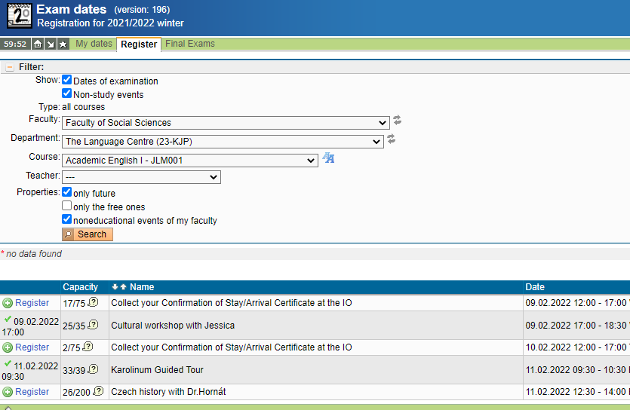

Q: When looking up the schedule I could see a time for lecture and a time for practice. By practice you mean seminars? And we have to sign up for both right?
IO: Yes, please register for both a lecture as well as a practical/ a seminar.

Q: The tandem Language mentioned before it doesn't have indication if it is for incoming students or what. Can we enroll on it?
IO: Yes, you can. It is JLB116

Q: To get the email from the university we have to enter CAS?
IO: Every student has to be enrolled in CAS. You need your student's personal number.

Q: What if I already have an ISIC card? Do I need to get one from Czech Republic?
IO: If you have an ISIC card already, this card should be working for discounts into museums, monuments, etc. in Prague, as well. However, we do recommend having also the CU card at least, that you will use to prove your student status in the Czech Republic, you can use it at the university’s libraries, etc.
Q:What if we didn't have the time to change the password?
IO: You need to write to the helpdesk.
Exchange student: ıs our CAS and SIS password the same?
IO: Yes, it is.
Q: I can't log on to either SIS or CAS. What happens if I forget my login details/password?
IO: The IO coordinator can help you with the personal number. The forgotten password can be reset again in CAS.
Q: I just noticed that my CAS password had expired already and filled in the form about it. Will there be time to get a new one before the course registration?
IO: Please write to the helpdesk (query theme: CAS login problem), use the personal number that was issued to you in the email.
Q: I still don't have my password and user to log in to CAS, who should I text for it? Thank you very much.
IO: Do check spam, promotions tab…. or check all incoming emails. In addition, check if you provided the same email address on your application form. The log-in will be sent to that email address. If nothing, please, contact the Help Desk.
Q: How can I tell if the courses are designated for Erasmus students or not? Most of the courses I chose are not available.
IO: When searching for a course in SIS module Subjects - state Class: Course for incoming students. See here.
Q: Should we rush to register or is there enough availability?
IO: We recommend registering as soon as possible as every course has a limited capacity.
Q: How do we know that the courses which are pre-approved from our home-university and in our LA aren’t at the same time? For example, if two courses are on the same day and time in the week?
IO: We recommend checking the courses before the course registration, thus you may have a better idea about their time slots for the winter semester. In the SIS, please, click on Subjects on the main board, then put the relevant code or name of the course into the search. Then click on the course and you will see the Schedule on the right side (below).
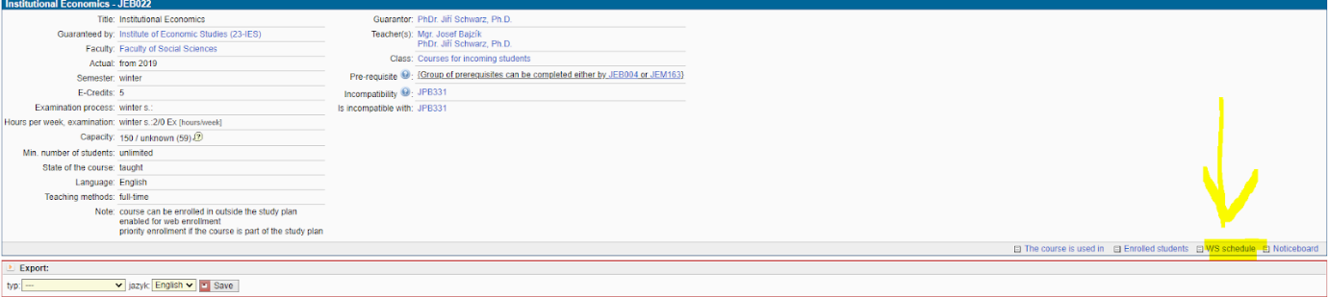
After, you see the time slots of the course.
Q: My home institution requires that the courses I follow are at least 2nd year courses but I could not find any information about that in the SIS course catalogue. Where can I find this information or does the Faculty not distinguish between which year of study a course belongs to?
IO: Unfortunately, the FSV UK does not make this kind of distinction.

Q: When will we know which classes we get a spot in? How many "plan b" courses do you recommend that we sign up for?
IO: You will know it straight away if you can enroll or be on the waiting list.
Q: My home university requires 15 ects of level 3/ 3rd year/advanced courses during exchange, but these courses are not in the "incoming students" category in course catalogue. Am I still allowed to take these courses? (e.g. advanced macro & advanced econometrics)?
IO: In general, incoming students may enroll only in courses assigned “Courses for incoming students” on SIS. But, if you really need to take the course, please, do not hesitate to contact the professor and specify the reason.
Q: As an exchange student, can we only register to classes that are for incoming students?
IO: Yes, it is preferred.
Q: Do we have a priority to register for classes we initially signed on the Learning Agreement?
IO: No, with the opening of the registration you are starting from scratch.
Q: In the schedule, some courses are given more than once a week, do we need to attend every one of them?
IO: Depends on the course. Some courses are composed of two sections (lectures and seminars) - then yes, both are compulsory. Sometimes you get a lot of options for a seminar - then you need to choose just one.
Q: I heard that some of the Courses listed on the subject list are already full since the local students had their Course registrations earlier than us. How do we know which ones are still available?
IO: When registering the system won’t let you enroll - it either means the course is full (then waiting list option is offered) or the course is not intended for Exchange students.
Q: Do I understand it correctly? If I want to enroll for the course in Czech (not for incoming students), I can't do it until I'll write you an email?
IO: You need approval of the professor first, then he/ she or we can register you. You will not be able to do it yourself.
Q: If I find a course from winter semester at your university which is similar to course from my home university in summer semester, can I replace it with this course?
IO: You need to contact your home university and have it approved by them first. There is no problem from our side.
Q: How do I know which course has a “research component” to it? This is required by my uni for at least 2 courses.
IO: Contact the course professor, please, if it is not stated on the course syllabus in SIS.
Q: If a master course's description excludes social science undergraduate students, does this apply to me as an Erasmus student?
IO: Unfortunately, yes.
Q: Is it possible to register for classes if the changes in learning haven't been approved yet? I am still waiting for my home university to approve them.
IO: If you have any doubts, please email your Coordinator from the International Office FSV CU.
Q: Will I know my schedule when signing up for the classes?
IO: Yes, every course should have the time mentioned in the syllabus.
Q: What if all the courses approved by my home uni are full and I won't be able to register for any of the subjects in my LA? What should I do in such a case? Create a new LA?
IO: You do not need to create a new one, but you will need to make changes to the original one and have them approved by your home university and then by your IO coordinator
Q: What if a class says that it is taught in Czech and English? Any idea how that works? Thank you!
IO: I suppose the teacher will be able to give you English instructions. In addition, check if there are two different available time slots of the same course. One of them can be taught in English only.
Q: I saw almost every sport course is in Czech. Don't you have sport courses in English?
IO: There are some, but yes very few. Nevertheless most of the teachers speak English, so you can email them and ask if it is ok to join the class even though you do not speak Czech.
Q: Can I sign up for courses in Czech?
IO: In general no. If you speak Czech (native or very knowledgeable) contact the professor and ask. If he/ she approves, they can add you to the course. If they can't, the IO coordinator can (but confirmation email from the professor must be forwarded).
Q: Do you have sports sections?
IO: At our faculty we don’t. But you can have a look at the Faculty of Arts where they have some allocated for our faculty.
Q: I have already gotten emails from a course, but they are in Czech and it is not one of the courses I’m in.
IO: If you forward us the email we will have a look at this and let you know what it is about.
Q: Can I sign for bachelor subjects even if I study a master degree?
IO: Yes, as a bachelor-level student you can register for a master-level course, and vice versa. However, please, be sure that the courses are acknowledged by your home university coordinator.
Q: Do you know roughly when the re-exams will be?
IO: This is solely each professor's decision.
Q: If we fail a course we take, is there such a thing as a make-up exam? I mean a new exam that can make up for the final exam?
IO: Yes, every student who fails an exam has the right to have a re-take.
Q: What grade (A-F) do we need to get to pass the test/exam?
IO: A-E = passed, F = failed
Q: Is it possible to attend classes without being assigned to them, additionally, without taking the exam?
IO: Lectures are open to the public but the room capacity is limited. Seminars only to registered students.
Q: Do we need to register somewhere for the student id?
Your student ID has been sent to you by email. It is a 8 digit number. In case you have not received login details to CAS, please contact your IO coordinator.

Q: will this meeting be recorded and if so where can we find the recording?
IO: Yes, it will be recorded and shared on the webpage https://fsv.cuni.cz/en/exchange/life/presentations.
Q: Will EU4+ students also have to confirm our arrival? I get an Erasmus+ grant as well, so I think I might
Yes, you will be able to get your certificate of arrival.

Q: Should everyone have to get the certificate of arrival? My university doesn’t require it
If your university does not require it, then you can skip it. Some universities requeries the confirmation of stay at the end of your mobility. But as per our experience, most of the Erasmus students will need in the beginning of the semester.

Q: Is it necessary to join all the coordinators academic zoom meetings, or just the one of our studies?
No, it is not. Join only those of which institute you are registering courses.
Q: I forgot to ask that before: Will the IO give us a digital copy of the certification of arrival in CU? We have to send it to our home university
When you come to the IO, talk to your IO coordinator, she can scan the confirmation for you.

